Red Ribbon Week: October 23-27

Theme Days

Monday: Be someone’s superhero, stay drug free!
(Superhero day)

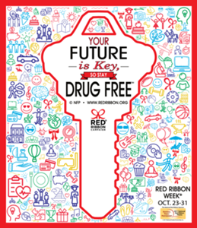
Tuesday: From head to toe I’m drug free!
(Crazy hair and Sock Day)

Wednesday: Team up against drugs!
(Sports wear)

Thursday: Rally in Red against drugs!
(Red, Black, White Day)

Friday: I’m a drug free proud panther!
(Wear SPE spirit wear)

