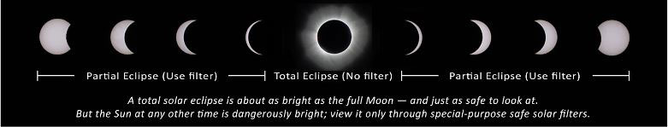
Graphic courtesy of NASA

Dear R7 Families-

Looking directly at the sun is unsafe except during the brief total phase of a solar eclipse (“totality”), when the moon entirely blocks the sun’s bright face. This will happen only within the narrow path of totality – which does not include any portion of our school district. The only safe way to look directly at the uneclipsed or partially eclipsed sun is through special-purpose solar shades, such as the ones approved by the Missouri Optometric Association for the Lees Summit R7 students and staff. These shades meet the ISO 12312-2 safety standards. As such, parents are encouraged to thoroughly read and observe the safety instructions from the NASA website listed below.

Please review the following guidelines before using the safety shades.
- Inspect the glasses before using them, and discard them if they are scratched or damaged. Read any instructions that accompany them.
- Children should be adequately supervised during the eclipse.
- Cover your eyes with the glasses before looking up at the sun. Do not remove the glasses while looking at the sun.
- Do not look at the sun through a camera or binoculars even with the glasses on.
- Since the Lee’s Summit R-7 area is slightly outside the path of totality, do not take off the glasses even when the eclipse is at its peak. The glasses can be taken off only if you are in a location within the path of totality, and only when the moon completely covers the sun’s bright face. As soon as the bright sun begins to reappear, put the glasses back on.
- If you normally wear eyeglasses, keep them on and put your eclipse glasses on over them.
- https://eclipse2017.nasa.gov/safety

We appreciate your support of our schools and wish you safe viewing for this momentous event.

